Help WF – Como aprovar workitem tipo TASK COMUM automaticamente

Este tipo de tarefa
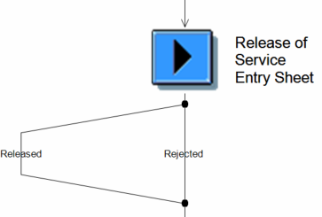

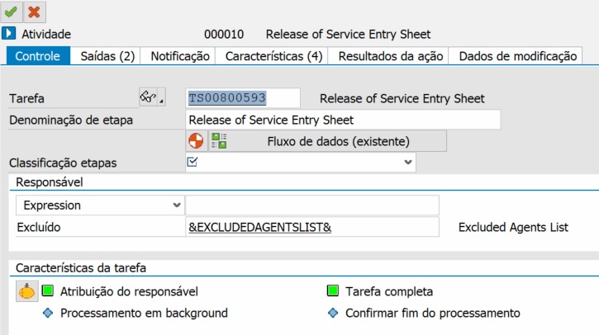

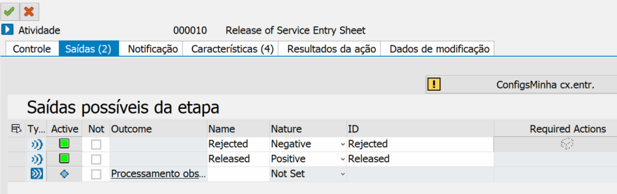

Tarefa
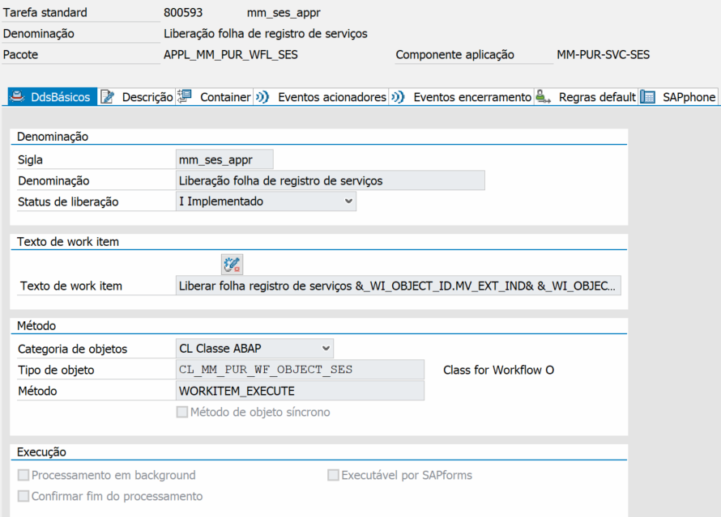

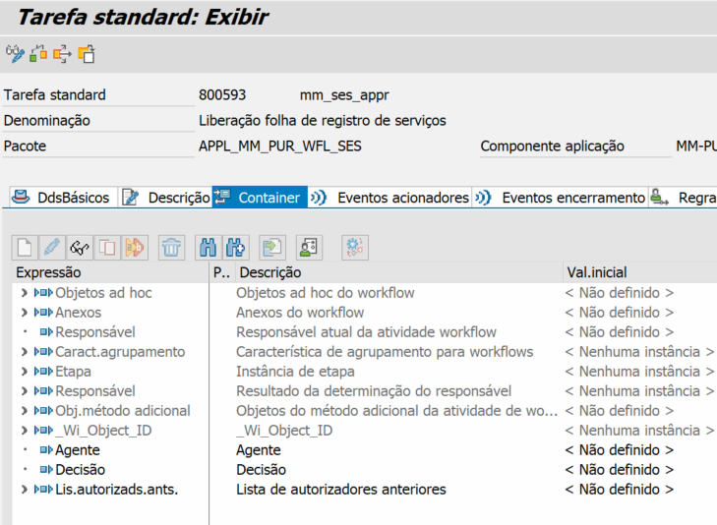

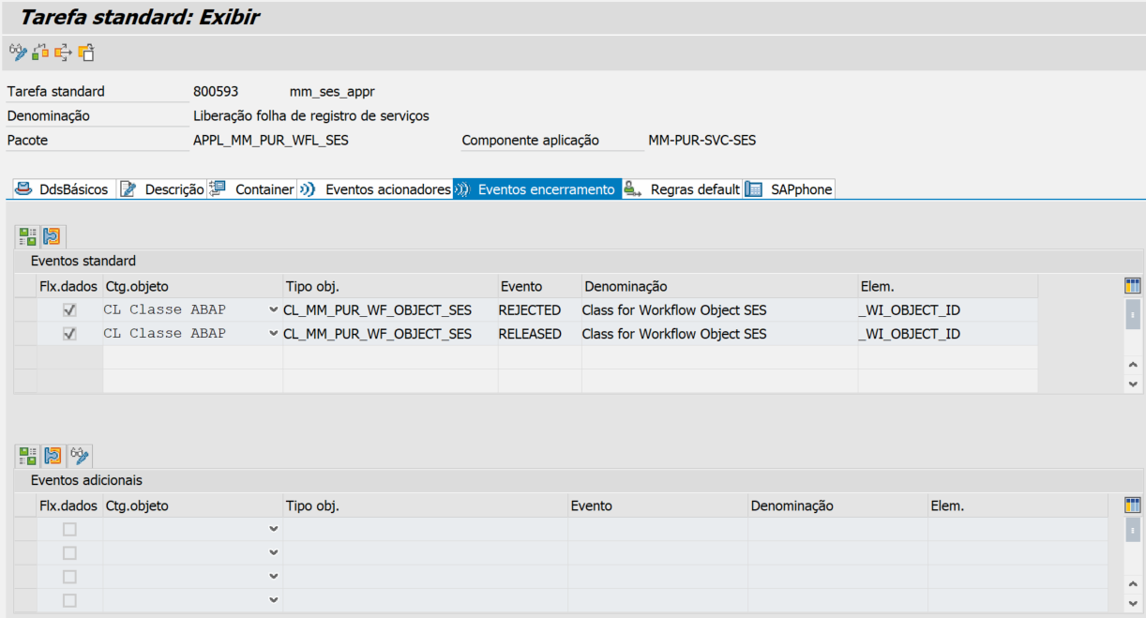

BADI de busca
Filtro: BUSINESSOBJECT
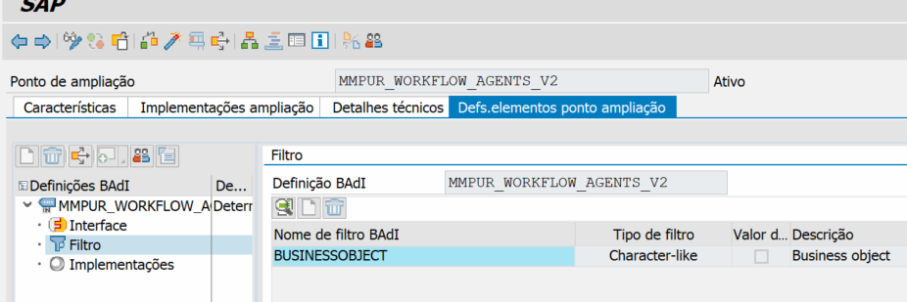

Filtro dentro da implementação
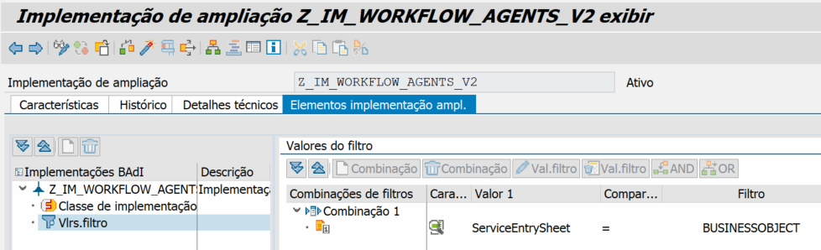
METHOD if_mmpur_workflow_agents_v2~get_approvers.
DATA:
lt_message TYPE TABLE OF swf_t100ms,
lt_approverlist TYPE mmpur_t_wfagent,
vl_scenario_id TYPE swd_wfd_id,
vl_object_id TYPE sibfboriid,
vl_nivel TYPE int1,
vl_nivelc TYPE char3,
vl_code TYPE zde_code_aprov,
vl_fb_name TYPE swwloghist-method,
lt_nivelcode TYPE ty_nivelcode_tt.
TRY .
"Encontra NIVEL/nivel + CODE
me->calculate_current_step_code(
EXPORTING
i_purchase_order = purchasingdocument
i_workflow_scenario = workflowscenario
IMPORTING
e_step = vl_nivel
e_code = vl_code
e_t_nivelcode = lt_nivelcode ).
CATCH cx_swf_flex_ifs_exception.
ENDTRY.
vl_nivelc = vl_nivel.
CASE workflowscenario.
WHEN 'WS00800321'.
zcl_wf_zportal_util=>definir_aprov_servicesheet(
EXPORTING
i_step = vl_nivelc
i_code = vl_code
i_purchasingdocument = purchasingdocument
i_workflowscenario = workflowscenario
i_purchasingdocumentitem = purchasingdocumentitem
i_nivelcode = lt_nivelcode
IMPORTING
e_approverlist = lt_approverlist
e_message = lt_message ).
IF lt_approverlist IS NOT INITIAL.
"Validar se precisará deletar em relação ao previousapproverlist
"Se já aprovou antes o mesmo aprovador atual, não precisa mais
LOOP AT lt_approverlist INTO DATA(ls_approverlist).
READ TABLE previousapproverlist INTO DATA(ls_previousapproverlist) WITH KEY businessuser = ls_approverlist.
IF sy-subrc = 0.
"limpar lt_message
REFRESH lt_message.
"Setar ls_aprovar_wi_automaticamente
" Pois se o aprovador atual é o mesmo que já aprovou do nível anterior
" A gente vai aprovar o work item automaticamente via código abap
" na função em background logo abaixo.
DATA(ls_aprovar_wi_automaticamente) = abap_true.
EXIT.
ENDIF.
ENDLOOP.
approverlist = lt_approverlist.
ENDIF.
vl_object_id = purchasingdocument.
vl_scenario_id = workflowscenario.
TRY .
"Acessa a Instancia do WF
DATA(lo_wf_inst) = cl_swf_flex_def_factory=>wf_inst_handler( ).
DATA(lt_instances) = lo_wf_inst->get_workflow_instances(
EXPORTING
iv_scenario_id = vl_scenario_id
iv_appl_obj_id = vl_object_id
iv_is_draft = abap_false
iv_context = || ).
CATCH cx_swf_flex_ifs_exception.
ENDTRY.
SORT lt_instances BY workflow_id DESCENDING.
READ TABLE lt_instances REFERENCE INTO DATA(lo_instance) INDEX 1.
"Gravar msgs de erro no log do WF
IF lt_message IS NOT INITIAL.
vl_fb_name = TEXT-001.
LOOP AT lt_message INTO DATA(ls_message).
CALL FUNCTION 'SWW_WI_LOG_WRITE_EXCEPTION'
EXPORTING
do_commit = abap_false
fb_name = vl_fb_name
wi_id = lo_instance->workflow_id
msgid = ls_message-msgid
msgno = ls_message-msgno
msgty = ls_message-msgty
msgv1 = ls_message-msgv1
msgv2 = ls_message-msgv2
msgv3 = ls_message-msgv3
msgv4 = ls_message-msgv4.
ENDLOOP.
ENDIF.
"Este é o caso de que o aprovador atual é o mesmo que já aprovou um nível anterior
"Então este work item será aprovado automaticamente pela função em background logo abaixo.
IF ls_aprovar_wi_automaticamente = abap_true.
DATA: ls_t100 TYPE swf_t100ms.
vl_fb_name = TEXT-001.
ls_t100-msgty = 'S'.
ls_t100-msgid = 'ZWF'.
ls_t100-msgno = '061'.
CALL FUNCTION 'SWW_WI_LOG_WRITE_SUCCESS'
EXPORTING
do_commit = abap_false
fb_name = vl_fb_name
wi_id = lo_instance->workflow_id
log_message = ls_t100.
TRY.
DATA lv_approver TYPE char12.
lv_approver = lt_approverlist[ 1 ].
CATCH cx_root.
ENDTRY.
CALL FUNCTION 'ZMMF0091' IN BACKGROUND TASK
EXPORTING
i_top_wi_id = lo_instance->workflow_id "ID do workflow (principal)
i_approver = lv_approver.
ENDIF.
ENDCASE.
ENDMETHOD.

BUSCAR CODE Atual do XML do WF Flexível
METHOD calculate_current_step_code.
DATA:
lv_xml_steps TYPE i,
lv_log_steps TYPE i,
lv_scenario_id TYPE swd_wfd_id,
lv_object_id TYPE sibfboriid,
ls_message TYPE swf_t100ms.
" Resultado da identificação do passo e aprovador
TYPES: BEGIN OF ty_current_step,
step_index TYPE i, " 1, 2, 3...
runtime_status TYPE string, " status do passo atual (ex.: NOT_STARTED, IN_PROGRESS...)
approver_code TYPE string, " conteúdo de <name> (ex.: 'SU')
approver_textid TYPE string, " atributo textId de <name>
artifact_id TYPE string, " atributo artifactId do <activity>
END OF ty_current_step.
DATA ls_current TYPE ty_current_step.
e_step = 0.
lv_object_id = i_purchase_order.
lv_scenario_id = i_workflow_scenario.
DATA(lo_wf_inst) = cl_swf_flex_def_factory=>wf_inst_handler( ).
DATA(lt_instances) = lo_wf_inst->get_workflow_instances(
EXPORTING
iv_scenario_id = lv_scenario_id
iv_appl_obj_id = lv_object_id
iv_is_draft = abap_false
iv_context = || ).
SORT lt_instances BY workflow_id DESCENDING.
READ TABLE lt_instances REFERENCE INTO DATA(lcl_instance) INDEX 1.
IF sy-subrc <> 0.
RAISE EXCEPTION TYPE cx_swf_flex_ifs_exception.
ENDIF.
"XML MAIN do Worfklow
DATA(lo_ixml) = cl_ixml=>create( ).
DATA(lo_stream_factory) = lo_ixml->create_stream_factory( ).
DATA(lo_document) = lo_ixml->create_document( ).
IF lo_ixml->create_parser(
document = lo_document
stream_factory = lo_stream_factory
istream = lo_stream_factory->create_istream_xstring( string = lcl_instance->xmlresource ) )->parse( ) <> 0.
RAISE EXCEPTION TYPE cx_swf_flex_ifs_exception.
ENDIF.
" 1) Passo atual + code
ls_current-step_index = 0.
ls_current-approver_code = ''.
ls_current-approver_textid = ''.
ls_current-artifact_id = ''.
ls_current-runtime_status = ''.
DATA(lo_pf_itr) = lo_document->create_iterator( ).
lo_pf_itr->set_filter( lo_document->create_filter_name_ns( name = 'processFlow' ) ).
DATA(lo_pf) = lo_pf_itr->get_next( ).
WHILE lo_pf IS BOUND.
DATA(lo_act_itr) = lo_pf->create_iterator( ).
lo_act_itr->set_filter( lo_document->create_filter_name_ns( name = 'activity' ) ).
DATA(lo_act) = lo_act_itr->get_next( ).
DATA(lv_completed_skipped) = 0.
WHILE lo_act IS BOUND.
DATA(lo_attr) = lo_act->get_attributes( ).
DATA(lo_rs) = lo_attr->get_named_item_ns( name = 'runtimeStatus' ).
DATA(lv_rs) = COND string( WHEN lo_rs IS BOUND THEN lo_rs->get_value( ) ELSE '' ).
CASE lv_rs.
WHEN 'CANCELLED'.
lv_completed_skipped = 0.
WHEN 'COMPLETED' OR 'SKIPPED'.
lv_completed_skipped = lv_completed_skipped + 1.
WHEN OTHERS.
" nada
ENDCASE.
lo_act = lo_act_itr->get_next( ).
ENDWHILE.
DATA(lv_target_index) = lv_completed_skipped + 1.
lo_act_itr = lo_pf->create_iterator( ).
lo_act_itr->set_filter( lo_document->create_filter_name_ns( name = 'activity' ) ).
lo_act = lo_act_itr->get_next( ).
DATA(lv_index) = 0.
WHILE lo_act IS BOUND.
lv_index = lv_index + 1.
IF lv_index = lv_target_index.
DATA(lo_attr2) = lo_act->get_attributes( ).
DATA(lo_artid) = lo_attr2->get_named_item_ns( name = 'artifactId' ).
IF lo_artid IS BOUND.
ls_current-artifact_id = lo_artid->get_value( ).
ENDIF.
DATA(lo_rs2) = lo_attr2->get_named_item_ns( name = 'runtimeStatus' ).
IF lo_rs2 IS BOUND.
ls_current-runtime_status = lo_rs2->get_value( ).
ENDIF.
DATA(lo_name_itr) = lo_act->create_iterator( ).
lo_name_itr->set_filter( lo_document->create_filter_name_ns( name = 'name' ) ).
DATA(lo_name) = lo_name_itr->get_next( ).
IF lo_name IS BOUND.
ls_current-approver_code = lo_name->get_value( ).
ENDIF.
EXIT.
ENDIF.
lo_act = lo_act_itr->get_next( ).
ENDWHILE.
ls_current-step_index = lv_target_index.
lo_pf = lo_pf_itr->get_next( ).
ENDWHILE.
e_step = ls_current-step_index.
e_code = ls_current-approver_code.
"2) Tabela completa (todos os steps)
DATA lt_all_steps TYPE STANDARD TABLE OF ty_nivelcode WITH EMPTY KEY.
DATA(lo_pf_itr_all) = lo_document->create_iterator( ).
lo_pf_itr_all->set_filter( lo_document->create_filter_name_ns( name = 'processFlow' ) ).
DATA(lo_pf_all) = lo_pf_itr_all->get_next( ).
WHILE lo_pf_all IS BOUND.
DATA(lo_act_itr_all) = lo_pf_all->create_iterator( ).
lo_act_itr_all->set_filter( lo_document->create_filter_name_ns( name = 'activity' ) ).
DATA(lo_act_all) = lo_act_itr_all->get_next( ).
DATA(lv_idx_all) = 0.
WHILE lo_act_all IS BOUND.
lv_idx_all = lv_idx_all + 1.
DATA ls_entry TYPE ty_nivelcode.
ls_entry-nivel = lv_idx_all.
DATA(lo_attr_all) = lo_act_all->get_attributes( ).
IF lo_attr_all IS BOUND.
DATA(lo_artid_all) = lo_attr_all->get_named_item_ns( name = 'artifactId' ).
IF lo_artid_all IS BOUND.
ls_entry-artifact_id = lo_artid_all->get_value( ).
ENDIF.
DATA(lo_rs_all) = lo_attr_all->get_named_item_ns( name = 'runtimeStatus' ).
IF lo_rs_all IS BOUND.
ls_entry-runtime_stat = lo_rs_all->get_value( ).
ENDIF.
ENDIF.
DATA(lo_name_itr_all) = lo_act_all->create_iterator( ).
lo_name_itr_all->set_filter( lo_document->create_filter_name_ns( name = 'name' ) ).
DATA(lo_name_all) = lo_name_itr_all->get_next( ).
IF lo_name_all IS BOUND.
ls_entry-code = lo_name_all->get_value( ).
SHIFT ls_entry-code LEFT DELETING LEADING space.
SHIFT ls_entry-code RIGHT DELETING TRAILING space.
ENDIF.
APPEND ls_entry TO lt_all_steps.
lo_act_all = lo_act_itr_all->get_next( ).
ENDWHILE.
lo_pf_all = lo_pf_itr_all->get_next( ).
ENDWHILE.
e_t_nivelcode[] = lt_all_steps[].
ENDMETHOD. "#EC CI_VALPAR

Como aprovar automaticamente a atividade
*-----------------------------------------------------------------------
FUNCTION zmmf0091.
*"----------------------------------------------------------------------
*"*"Interface local:
*" IMPORTING
*" VALUE(I_TOP_WI_ID) TYPE SWWWIHEAD-TOP_WI_ID
*" VALUE(I_APPROVER) TYPE CHAR12
*"----------------------------------------------------------------------
* WAIT UP TO 10 SECONDS.
"buscar work item que acabou de ser criado e está como status=READY
"a partir do top work item ID (ID do workflow principal)
DATA lv_cont_loop TYPE i.
DO.
SELECT wi_id
FROM swwwihead
INTO @DATA(lv_ready_wi_id)
WHERE top_wi_id = @i_top_wi_id "6086476
AND wi_stat = 'READY'
ORDER BY PRIMARY KEY.
ENDSELECT.
IF sy-subrc = 0 .
DATA(lv_achou) = abap_true.
EXIT.
ENDIF.
ADD 1 TO lv_cont_loop.
IF lv_cont_loop > 5000.
EXIT.
ENDIF.
ENDDO.
IF lv_achou = abap_false.
RETURN.
ENDIF.
* IF sy-subrc <> 0.
* RETURN.
* ENDIF.
" TESTE 13/05 INI
* Caso o status esteja como READY, devemos modificar para STARTED
* OBS.: NÃO FUNCIONA P/ WF FLEXÍVEL !!!
* DATA:
* lv_ret_code TYPE sy-subrc,
* ls_new_status TYPE swr_wistat,
* lt_message_lines TYPE TABLE OF swr_messag,
* lt_message_struct TYPE TABLE OF swr_mstruc.
* CALL FUNCTION 'SAP_WAPI_SET_WORKITEM_STATUS'
* EXPORTING
* workitem_id = lv_ready_wi_id
* status = 'STARTED'
* user = i_approver
* do_commit = abap_true
* IMPORTING
* new_status = ls_new_status
* return_code = lv_ret_code
* TABLES
* message_lines = lt_message_lines
* message_struct = lt_message_struct.
*
* WAIT UP TO 1 SECONDS.
" TESTE 13/05 FIM
DATA:
lv_object_id TYPE mmpur_key,
lo_wfl_object_ses TYPE REF TO cl_mm_pur_wf_object_ses,
lv_decision TYPE swc_elem,
ls_object TYPE swr_obj_2,
ls_return TYPE bapiret2.
"Setar decisão=APPROVE=0001
lv_decision = if_mm_pur_workflow_c=>gc_workitem_released_event.
"Access the workflow data
CALL FUNCTION 'SAP_WAPI_GET_OBJECTS'
EXPORTING
workitem_id = lv_ready_wi_id
IMPORTING
leading_object_2 = ls_object.
"Get Document number
lv_object_id = ls_object-instid.
"Execute the workitem
CREATE OBJECT lo_wfl_object_ses
EXPORTING
iv_object_id = lv_object_id.
sy-uname = i_approver.
"Approve work item
CALL METHOD lo_wfl_object_ses->set_workitem_executed
EXPORTING
iv_wiid = lv_ready_wi_id
iv_decision = lv_decision
"iv_note = lv_note
IMPORTING
es_return = ls_return.
ENDFUNCTION.

